Self-Quiz 3 Questions
Activity Three: The ORF Finder
Why is there more than one reading frame for a nucleotide sequence?
Some sequences are too long to have only one reading frame
Reading frames overlap one another
There are often more than one start (methionine) codons in a sequence
A codon encompasses 3 nucleotides, one sequence can produce different reading frames depending on which nucleotide is read first

How many reading frames exist for a double-stranded DNA sequence?
Two
Four
Six
Three

Which of the following best describes an Open Reading Frame (ORF)?
A sequence of nucleotides that contain a start and stop codon in any order
A reading frame that contains a start codon, a number of codons for amino acids, and then a stop codon
A reading frame with multiple start codons
A sequence of nucleotides without any stop codons

Assume that all the following ORF’s are generated from the same mRNA transcript. Which would be the best one to select for the gene annotation?

In the following figure, what indicates that an ORF has been selected for the annotation?
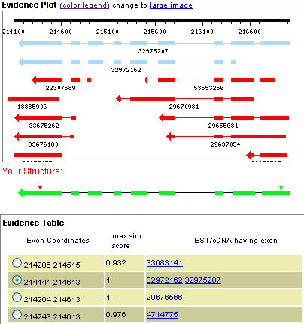
The green dot next to the exon in the evidence table
There is a proposed gene model under the words “Your Structure”
Multiple EST/cDNA evidence supports the proposed gene model
The green and red triangles show the protein coding region on the proposed gene model

Which one of the statements below correctly identifies the problem(s) with the selected ORF in the following figure?
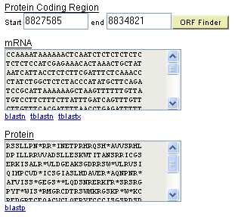
The protein coding region is too long and not a multiple of 3.
The mRNA transcript does not start with AUG
The amino acid sequence is interrupted multiple stop codons
The amino acid sequence does not start with M (methionine) and also contains multiple stop codons
Self-Quiz 3 Questions & Answers
Activity Three: The ORF Finder
Why is there more than one reading frame for a nucleotide sequence?
Some sequences are too long to have only one reading frame
Reading frames overlap one another
There are often more than one start (methionine) codons in a sequence
A codon encompasses 3 nucleotides, one sequence can produce different reading frames depending on which nucleotide is read first

How many reading frames exist for a double-stranded DNA sequence?
Two
Four
Six
Three

Which of the following best describes an Open Reading Frame (ORF)?
A sequence of nucleotides that contain a start and stop codon in any order
A reading frame that contains a start codon, a number of codons for amino acids, and then a stop codon
A reading frame with multiple start codons
A sequence of nucleotides without any stop codons

Assume that all the following ORF’s are generated from the same mRNA transcript. Which would be the best one to select for the gene annotation?

In the following figure, what indicates that an ORF has been selected for the annotation?
The green dot next to the exon in the evidence table
There is a proposed gene model under the words “Your Structure”
Multiple EST/cDNA evidence supports the proposed gene model
The green and red triangles show the protein coding region on the proposed gene model

Which one of the statements below correctly identifies the problem(s) with the selected ORF in the following figure?
The protein coding region is too long and not a multiple of 3.
The mRNA transcript does not start with AUG
The amino acid sequence is interrupted multiple stop codons
The amino acid sequence does not start with M (methionine) and also contains multiple stop codons

