Self-Quiz 2 Questions
Activity Two: Constructing a Proposed Gene

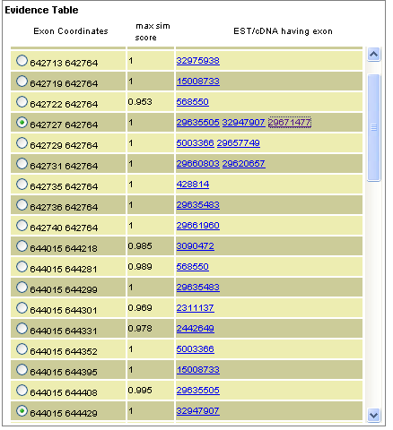Document name: evidencetable2
Which of the following statements is true regarding the above Evidence Table?
Those exons with an identical second coordinate are the same.
Each of the first nine exons is successively shorter than the previous exon.
The exons are organized by the EST/cDNA ID number.
The lower the Max Sim Score the better.

Some of the exons in the table above have multiple ID numbers in the right column. Which of the following best explains the reason for this?
There are multiple introns interrupting these exons.
There are multiple start codons for these exons
The same exon can be found on multiple sequences
These exons are can be found in multiple species

Based on the information in the above table, which exon is least likely to provide good evidence for a proposed gene model?
642713 642764
642727 642764
644015 644218
644015 644331

Based on the information in the table above, which exon is the longest?
642713 642764
642727 642764
644015 644218
644015 644331

Based on the information in the above table, which of the following EST or cDNA sequences contains multiple exons?
29635505
32947907
5003366
29660803

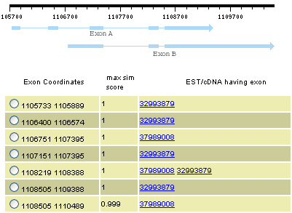 Document Name: quiz2
Based on the information in the above figure, which of the following statements is correct?
cDNA A is 32993879 and cDNA B is 37989008.
cDNA B is 32993879 and cDNA A is 37989008.
The information in the evidence table does not match the structures in the Evidence Plot.
These two cDNA do not contain a common exon.

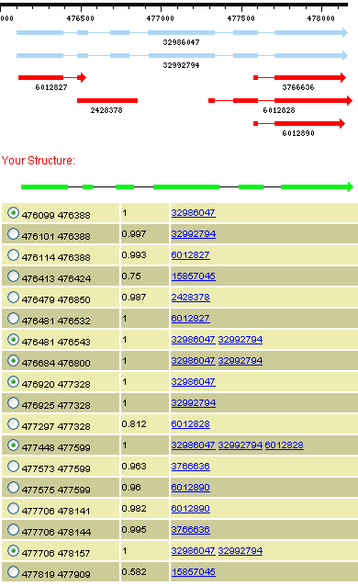Document Name: quiz2b

Use the information in the above Evidence Table to determine which complete structure in the Evidence Plot supports the proposed gene model.
6012827
6012828
32986047
32992794

Self-Quiz Questions and Answers
Activity Two: Constructing a Proposed Gene

Document name: evidencetable2
Which of the following statements is true regarding the above Evidence Table?
Those exons with an identical second coordinate are the same.
Each of the first nine exons is successively shorter than the previous exon.
The exons are organized by the EST/cDNA ID number.
The lower the Max Sim Score the better.

Some of the exons in the table above have multiple ID numbers in the right column. Which of the following best explains the reason for this?
There are multiple introns interrupting these exons.
There are multiple start codons for these exons
The same exon can be found on multiple sequences
These exons are can be found in multiple species

Based on the information in the above table, which exon is least likely to provide good evidence for a proposed gene model?
642713 642764
642727 642764
644015 644218
644015 644331

Based on the information in the table above, which exon is the longest?
642713 642764 (51)
642727 642764 (37)
644015 644218 (203)
644015 644331 (316)

Based on the information in the above table, which of the following EST or cDNA sequences contains multiple exons?
29635505
32947907
5003366
29660803

Document Name: quiz2
Based on the information in the above figure, which of the following statements is correct?
cDNA A is 32993879 and cDNA B is 37989008.
cDNA B is 32993879 and cDNA A is 37989008.
The information in the evidence table does not match the structures in the Evidence Plot.
These two cDNA do not contain a common exon.

Document Name: quiz2b

Use the information in the above Evidence Table to determine which complete structure in the Evidence Plot supports the proposed gene model.
6012827
6012828
32986047
32992794

