Self-Quiz 4 Questions

Activity Five: GAEVAL
Which of the following flags indicates that no splice sites were confirmed, but that there is some alignment (within the exon boundaries)?
A.
B.
C.
D.
E.

Which of the following flags indicates that all splice sites are aligned, however there are some gaps in the coverage between splice sites
A.
B.
C.
D.
E.

Which flag should be assigned to this annotation?
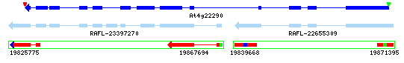
File name: fission
A.
B.
C.
D.

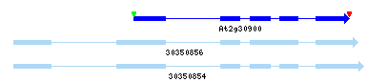
File name: unext
Which flag should be assigned to the above annotation?
A.
B.
C.
D.

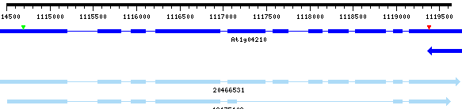
File name: imagesplice
Which flag should be assigned to the above annotation?
A.
B.
C.
D.

Self-Quiz 4 Questions

Activity Five: GAEVAL
Which of the following flags indicates that no splice sites were confirmed, but that there is some alignment (within the exon boundaries)?
A.
B.
C.
D.
E.

Which of the following flags indicates that all splice sites are aligned, however there are some gaps in the coverage between splice sites
A.
B.
C.
D.
E.

Which flag should be assigned to this annotation?
File name: fission
A.
B.
C.
D.

File name: unext
Which flag should be assigned to the above annotation?
A.
B.
C.
D.

File name: imagesplice
Which flag should be assigned to the above annotation?
A.
B.
C.
D.

