Name _____________________________________ Class Period ______ Date _____________

Gene Annotation
Activity Six: Gene Annotation Practice Session
Briefly describe what is wrong with each of the practice annotations in this section and describe how the annotations should be modified

- ________________________________________________________________________ ________________________________________________________________________
________________________________________________________________________
________________________________________________________________________

- ________________________________________________________________________ ________________________________________________________________________
________________________________________________________________________________________________________________________________________________

- ________________________________________________________________________ ________________________________________________________________________
________________________________________________________________________
________________________________________________________________________

- ________________________________________________________________________ ________________________________________________________________________
________________________________________________________________________________________________________________________________________________

Practice Annotation #1
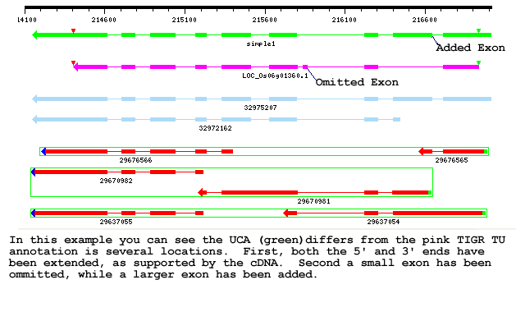
Practice Annotation #2
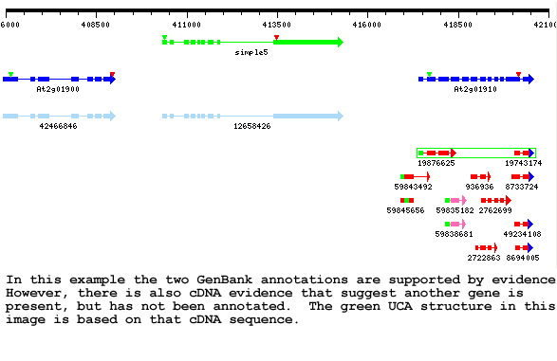

Practice Annotation #3
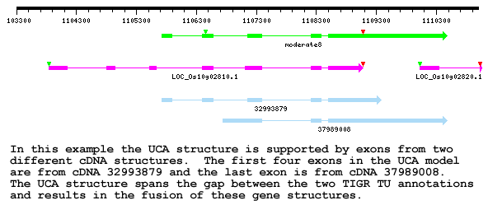

Practice Annotation #4
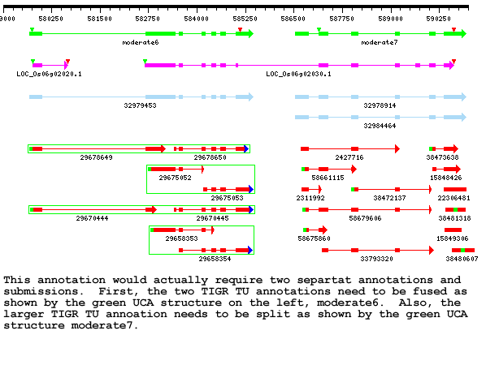

The Evidence Plot and the Evidence Table
- The Evidence Plot
- The entire structure (all of the exons) are added to the (green) gene model
- First click and it is selected (not the other exons on the same structure) on the second click it is deselected.
- The coordinates of the exon correspond to nucleotide bases in the genome, basically defining where the exon starts and stops in the sequence a chromosome
- The Max Sim Score and the number of cDNA and EST structures that contain the exons in question
- A color block represents a groups of variants for the same exon, so only one should be selected for each gene model
- Exons

